**Quiz for Java Programming** (Tutor: cyd@bupt.edu.cn)

Unit02-Object Oriented Programming-1

1. [T/F] The main function is in a class named MyClass. Can we create an instance of MyClass in the main function? T
2. An array in java is an Object and in C++ is a series of elements. Moreover, the array name in java is a class and in C++ is a constant pointer.
3. [T/F] We can create an array in java by: double myList[10];F
4. [T/F] A ragged array can hold data of different types. F

**编程题**：注意以下题目应使用git 工具管理代码，需将代码托管到老师指定的网站中

1. Write a class MyClass with an integer member "one" and a static integer member "two" as well as the main function. Create an instance of MyClass in main(). Output the value of member "one" and "two".

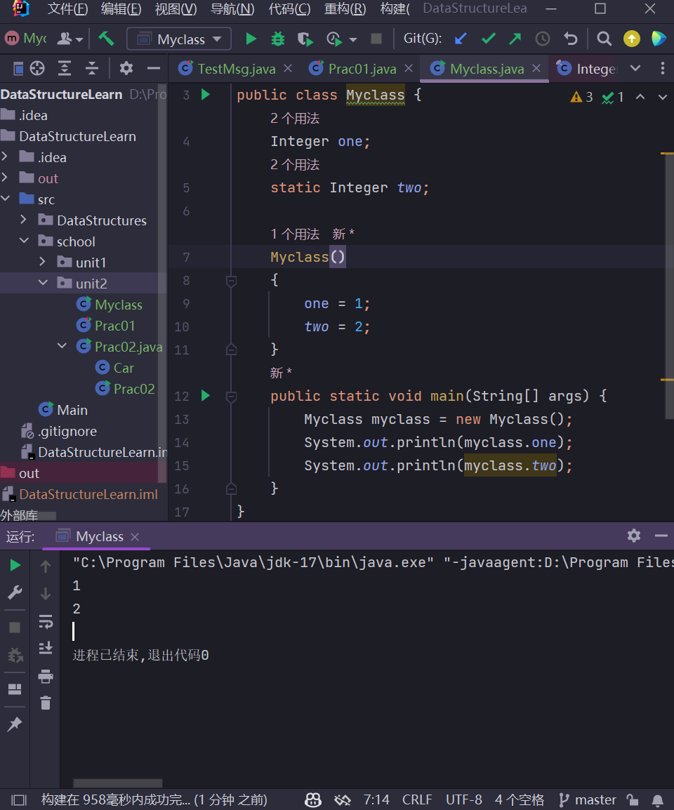

1. Separate the main function from MyClass in Quiz 5 and put main() into MainClass. Read in two integers and assign to the MyClass members "one" and "two". Then output the two member variables.

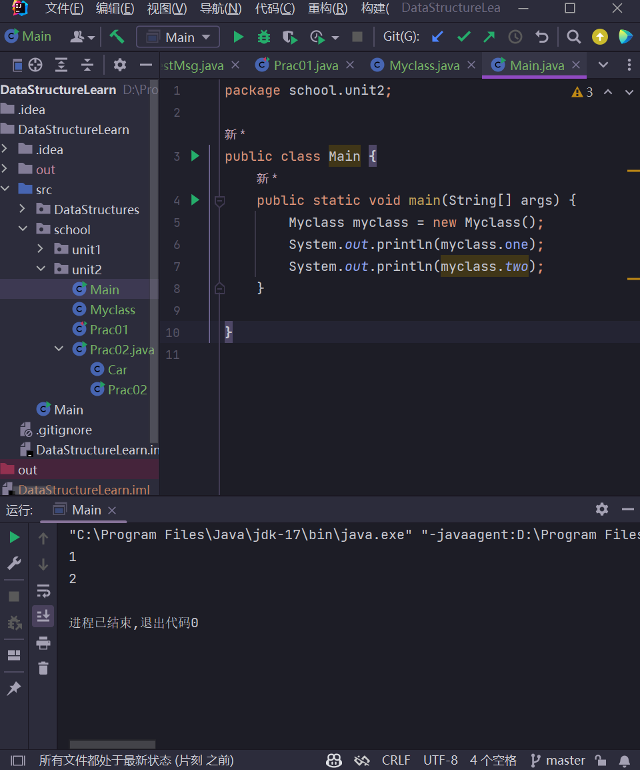

1. Write a function int [] reverse(int [] arr) which will reverse the elements in arr. Write a function void print(int [] arr) to output the array. In your main function, call these two functions as below and ***discuss*** why the outputs are the same. print(reverse(myArray)); print(myArray);

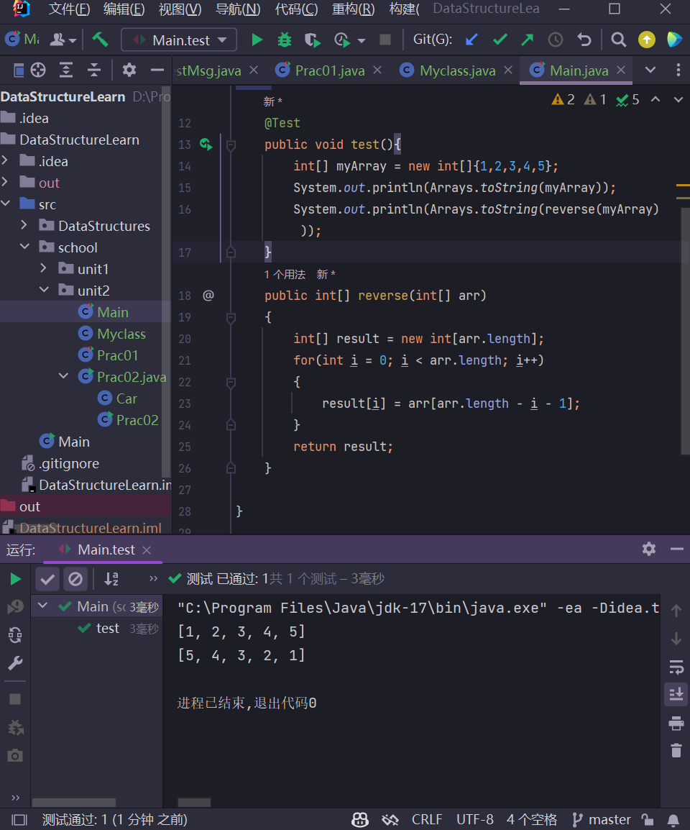

为什么我的可以正常倒置呢,哦,原来我的reverse函数是创建了一个新的数组来接受倒置的数据,而不是直接修改传入的数组,如果直接修改数组的话,由于java是值传递,只是将数组的地址传入函数中,就算你在函数里折腾把函数中指针指向数组内容改变了,可退出函数后会清空对应堆栈,变成原来主函数的堆栈,因此指针访问的是原来的主函数堆空间中对应的原来的数组内容,因此print出来的结果是一样的,解决方法可以是创造一个包装类,里面的成员变量存入数组,然后将包装类传入函数中将成员变量进行操作修改

1. Create a 3x3 2d array. Fill in the array with number 1-9 (randomly or not, YOU decide). Output it.

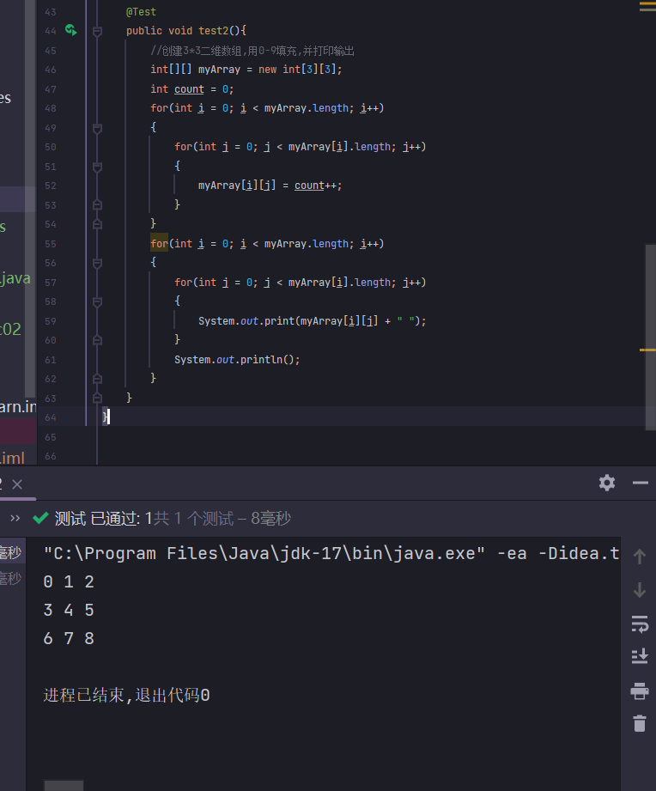

1. Create a ragged array as below. Output the array and the length of each line. 'a', 'b', 'c', 'd',

'x', 'y', 'z', '1', '2',

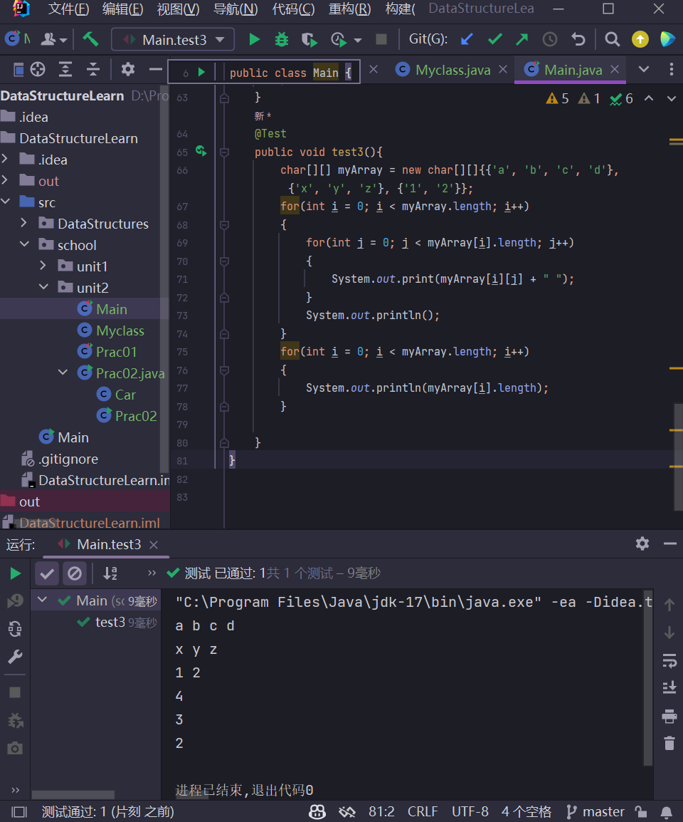

1. Write a function swap(DataType x, DataType y) to try exchanging the value of x and y. Test swap() in main(). 1) Make "DataType" as "int" and see the results; 2) Make "DataType" as "Integer" and see the results. Compare the results and tell the reasons.

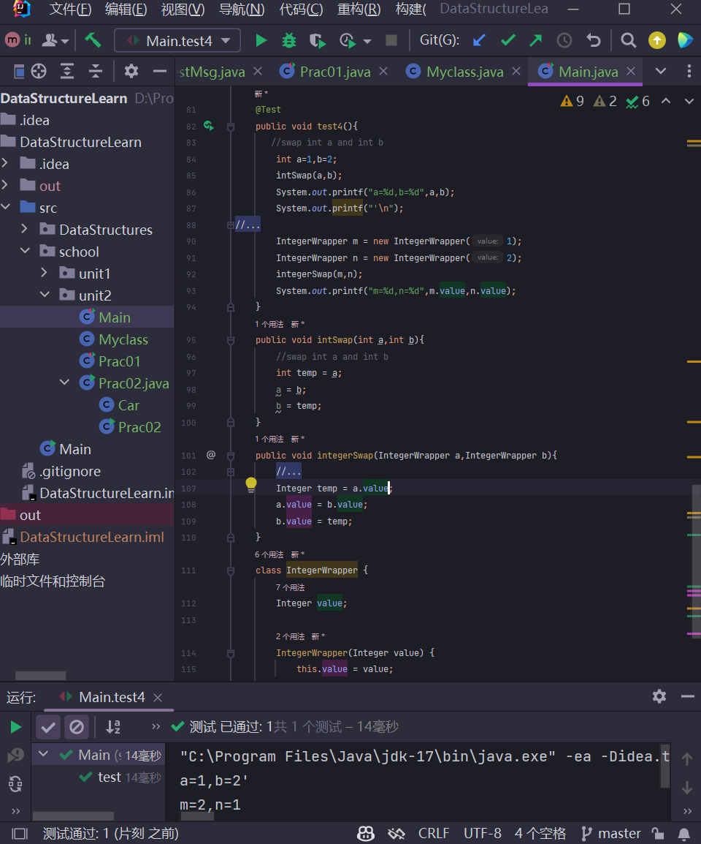

Int类型是值传递,传入函数的是int的副本,因此不会修改主函数中的int值,而integer类型是引用传递,引用传递可以通过指针改变指向结构的内容,即存放在主函数堆空间的Integer的值,然而如果直接用Integer传入的话其实也无法直接交换,只有将integer放入包装类中,在包装类中进行成员变量值的交换才可以真正做到输出交换后的值